UNIVERSITY MANAGEMENT SYSTEM

Project submitted to the
SRM University – AP, Andhra Pradesh
for the partial fulfillment of the requirements to award the degree of

Bachelor of Technology
In
Computer Science and Engineering
School of Engineering and Sciences
Submitted by
Y Swathi Priya – AP22110011285
Sk Kulsoom Banu – AP22110011250
S Akhila – AP22110011282

S Meghana – AP22110011461

Under the Guidance of
Dr. Kavitha Rani

SRM University AP
Neerukonda, Mangalagiri, Guntur
Andhra Pradesh – 522
Members contribution

AP22110011285
- Created Splash Screen
- Created Login Page
- Designed Conn class for database connection
- Made main_class
AP22110011250
- Designed Add Faculty form
- Developed Update Student and Update Teacher forms
- Added Search functionality
- Created Print and View Details (Student & Teacher) features
AP22110011282
- Helped with main_class
- Created database in XAMPP and imported SQL file
- Created Add Student form
- Created feature to Enter Marks for each student according to the semester
AP22110011461
- Made View Marks for each semester
- Helped with main_class
- Set up the project environment (tools, libraries, etc.)
- Made the project report

Abstract

This University Management System is a Java desktop application developed using Java Swing and MySQL. It is an easy management system for student and faculty information in a university. The application supports features like adding, editing, viewing, and deleting records of students and teachers. It also includes facilities for login, mark entry by teachers, and viewing marks semester-wise. It is built with a MySQL database by implementing JDBC for storage and retrieval of data. There is a easy-to-use interface for the administrator and the staff to administer online university functions.

Basic features

1. User authentication
• Class: Login class
• Description: Simple database authentication using username and password.
• Components:
- For username, utilize JTextField.
- For password, utilize JPasswordField.
- Simple error-handling and validation
Java Concepts: Swing components, JDBC (database connection), Exception Handling, String Handling, Input Validation

2. CRUD operations for faculty
• Implemented: TeacherDetails, AddFaculty, UpdateTeacher
• Described:
Create new teacher profiles and view and edit the teacher data.
• Components:
- Faculty management is identical to student management.
- Creation of Employee ID
Java Concepts: Swing, JDBC, String Handling, Event Handling, Input Validation, use of Auto-ID generation logic

3. CRUD operations on students
• Implemented: AddStudent, StudentDetails, UpdateStudent
• Described:
Insert new records of students and retrieve or look at the records for students and modify records.
• Components:
- Student form field data
- Database insert and update actions
- Display a table with search
Java Concepts: Event Handling, JDBC (SELECT, DELETE, UPDATE, INSERT), Swing (JButton, JTable, JTextField), ResultSet

4. Simple Data Display
- Implementation: TeacherDetails and StudentDetails
- Described:
Presentating of records in tabular form and basic search functionality.
- Components:
  - Using DbUtils to convert a JTable to a ResultSet.
  - Filtering the drop-down menu
Java Concepts: JTable, DbUtils, JDBC, ResultSet, JComboBox, Event Handling

5. Handling Inputs from Forms
- Implementation: Each class related to the form
- Described:
Getting user input using different controls and basic validation (e.g., required fields).
• Components:
  - JTextField, JDateChooser, and JComboBox
  - Handling form submission
Java Concepts: Swing (form controls), Event Handling, Data Conversion (e.g., dates), Input Valid

Advance Features

1. Managing Examination Marks
- Implementation: EnterMarks, ExaminationDetails
- Description:
Semester-based marks input system and depending upon the subject marks are entered.
- Components:
Semester-based organization, dynamic subject handling and mouse event handling for table
Java Concepts:
Swing components (JTable, JTextField)
Event Handling (MouseListener, ActionListener)
JDBC for dynamic data handling
Object-Oriented Design (modular classes separation)

2. Managing Database Transactions
- Implementation: Conn class and all data operations
- Description:
Single instance connection pooling
Prepared statement usage
Transaction management
- Components:
SQL injection security
Resource handling
Parameter queries
Java Concepts:
JDBC (PreparedStatement, Connection, ResultSet)
Exception handling (try-catch-finally)
Transactions (commit, rollback)

3. Advanced UI Components
- Implementation: Multiple classes
- Description:
JDateChooser for date selection
Click event handlers on interactive tables
Printable views for tables
- Components:
Third-party component integration
Custom table display
Printing capability
Java Concepts:
Java Swing (JTable, JDateChooser, JPanel)
Third-party libraries (JDateChooser)
Print API (print() method on JTable)
Custom cell display (TableCellRenderer)

4. Event-Driven Architecture
- Implementation: All classes implementing ActionListener
- Description:
Event handling mechanism and flexible action handling
- Components:
Multiple sources of events
Actions depending on the context
Event passing
Java Concepts:
Interfaces like ActionListener, ItemListener
Event handling by listeners
Logical decision based on ActionEvent.getSource()

5. Data Relationship Management
- Implementation: EnterMarks with student/semester/subject relations
- Description:
Relational data integrity preservation
Constructing complex queries
- Components:
Foreign key relationship
Multi-table processing
Data consistency
Java Concepts:
Error handling when constraints are broken
Representing relationship in Java classes (encapsulation)

1. Introduction
In a time of digitalization, the requirement for effective and automated management systems in educational institutions has become more essential than ever before. Handling student records, faculty information, academic performance, and scheduling manually not only leads to redundancy but also risks inconsistency in data and administrative delays. To counter such limitations and maximize institutional productivity, the University Management System has been implemented as a Java-based desktop application.
The system takes advantage of Java as the front-end interface and business logic and uses MySQL as the back-end database for secure storing and handling the data. Interfacing with the application and database is ensured by using MySQL Connector/J 9.2.0, allowing both components to easily communicate and function in an optimized way. Made by using IntelliJ IDEA, the system has class-based, module-like architecture with high maintainability, readability, and scalability.
University Management System is customized for administrative purpose and offers a centralized system for handling multiple academic and institutional tasks like entry/updating faculty and student information, mark entry and display of students, exam scheduling, and roll-number based search of students. Streamlining these operations, the system minimizes the scope of manual error, enhances data precision, and facilitates informed decision-making due to quick and easy access to key information.

Objectives:
The primary objectives of the University Management System are:
- Automation of University Operations -To eliminate manual record-keeping by automating student administration, teacher administration, academic performance, and exam timetables.
- Efficient Data Management -To store safely, retrieve, and manage student and teacher data in a central MySQL database.
- User-Friendly Interface-To provide an easy-to-use and user-friendly GUI through which administrators can perform tasks without much technical knowledge.
- Real-Time Record Handling-To facilitate real-time addition, modification, and retrieval of records for faster and more credible decision-making.
- Scalability and Maintainability-To enable the system to be developed with a modular class-based architecture that would be able to handle future extension and maintenance.
- Error Reduction-To reduce the possibility of entry errors and redundancy by validating inputs and minimizing human intervention.

2. Java concepts and implementation details

Overview
University Management System is a Java Swing application that offers functionality for managing faculty and student data, such as student marks, teacher data, and exam results. Data is stored in a MySQL database, and the system is based on a Model-View-Controller (MVC) architecture pattern.

Java Concepts Applied

1. Object-Oriented Programming (OOP)
Implementation:
All the classes in the system demonstrate OOP principles:
- Encapsulation: Data fields being private are accessed via methods
- Inheritance: Subclasses inherit JFrame and implement interface classes such as ActionListener
- Polymorphism: Overriding actions in actionPerformed() in classes
- Abstraction: Hiding complex database operations behind simple method calls
Reasoning:
OOP brings organization and structure to the application. Encapsulating data and behavior that are related in classes makes the code reusable and maintainable. Inheritance of JFrame enables every screen to take advantage of existing window functionality and add custom functionality.

2. Event-Driven Programming
Implementation:
- Classes implement ActionListener interface
- Such as buttons add listeners using addActionListener()
- The actionPerformed() method dispatches events
Reasoning:
GUI applications need event-driven design because it allows the application to respond to user events (button clicks, menu selections) in a non-blocking way, which is required for a responsive user interface.
3. Database Connectivity (JDBC)
Implementation:
- Conn class manages database connections
- PreparedStatement for parameterized queries
- ResultSet manages query results
- CRUD operations performed on all data management classes
Justification:
JDBC offers a standard means of relational database interaction. Prepared statements avoid SQL injection attacks. The Conn class supports centralized management of connections for code reuse and uniform database access.

4. Exception Handling
Implementation:
- Try-catch blocks surround database operations
- SQLException handling and general Exception handling
- Helpful error messages through JOptionPane
Explanation:
Justification:
Good exception handling allows the application to recover gracefully from exceptions such as database connectivity problems or bad user input, instead of crashing. It also gives users useful feedback.

5. Swing Components
Implementation:
- Overuse of JFrame, JButton, JTextField, JLabel, JTable, etc.
- Layout management (mostly null layout with absolute positioning)
- Personalized rendering through DbUtils.resultSetToTableModel()
Justification:
Swing includes an entire set of platform-independent, customizable GUI components. Although absolute positioning complicates responsive design, it provides precise control over where components are placed.

6. Collections Framework
Implementation
- Choice elements for drop-downs
- JComboBox using String arrays
- JTable models for tables
Rationale:
Java Collections provide efficient data structures to deal with collections of objects. Choice and JComboBox components utilize them to present users with options in a structured form.

Classes and Interfaces Used
Core Java Classes/Interfaces:
1. JFrame - Base window class for all windows
2. ActionListener - Interface to handle button clicks
3. JButton, JTextField, JLabel, JTable - UI components
4. Connection, Statement, PreparedStatement, ResultSet - JDBC classes
5. MouseAdapter - For handling table row clicks
6. JScrollPane - For scrollable content areas
7. JOptionPane - For dialog messages
8. JDateChooser (external library) - For picking date

Application-Specific Classes:
1. Login - Authentication screen
2. AddStudent - Add new student records
3. updateStudent - Update records of existing students
4. StudentDetails - Search and display students' information
5. AddFaculty - Insert new teacher records
6. UpdateTeacher - Update records of current teachers
7. TeacherDetails - View and search for teacher information
8. EnterMarks - Enter student exam marks
9. ExaminationDetails - View examination results
10. Conn - Database connection manager

Step-by-Step Detailed Implementation
1. Database Setup
The system uses a MySQL database named "universitymanagement" with the following tables:
- Student - Student's personal and academic information
- teacher - Faculty details
- marks - Students' marks
- login - User credentials

2. Connection Management
The Conn class holds all the database connections:
- Loads MySQL JDBC driver
- Establishes a connection with DriverManager
- Creates statement object for queries
- Hardcoded connection parameters (username: root, no password)

3. User Authentication
Login class:
- Offers username/password fields
- Verifies credentials with login table
- Success, launches main application (main_class)

4. Student Management
AddStudent
- Compiles academic and personal data
- Random generation of roll numbers
- Adds record in student table

updateStudent
- Loads current student data by roll number
- Facilitates address, contact, and academic update
- Updates student table with modifications

StudentDetails
- Displays all the students in a table
- Search by roll number
- Add, update, or print record options

5. Faculty Administration
AddFaculty
- Collects teacher data
- Generates employee ID
- Inserts into teacher table

Redefine
- Loads instructor information by employee ID
- Updates contact and professional information
- Saves changes to teacher table

TeacherDetails:
- Displays all the faculty in a table
- Search by employee ID
- Menu options for adding, modifying, or printing records

6. Examination System
EnterMarks:
- Select student by roll number and semester - Input 5 subjects' grades - Storage of data in marks table ExaminationDetails: - Shows student list - Click on student to view marks - "Result" button shows in-depth marks 7. Common Patterns - Each screen inherits JFrame for window functionality - Binds ActionListener to handle button press - Utilizes JOptionPane for user feedback - Encapsulating database operations in try-catch blocks - Consistent UI with color-coded backgrounds

3. Application code
https://github.com/yakkaluruswathipriya/University-Management
4. Demonstration

1. Splash Screen

2. Login Screen
Description:
This is the entry point of the University Management System. Users (Admin, Teachers, etc.) enter their credentials to securely log into the system.

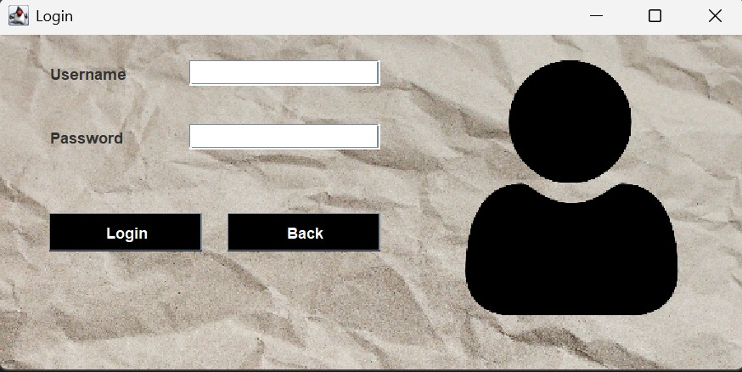

3. Dashboard
Description:
The dashboard is the central hub after login, displaying the background UI and a menu bar with categorized options to manage the university's operations.
Menu Categories:
- New Information
- View Details
- Examination
- Update Details
- Exit

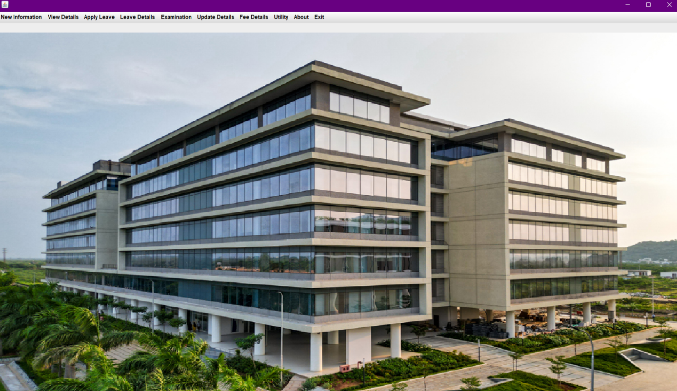

4. Teachers Section

Description:
Manage all teacher-related data—add new teachers, view or update faculty profiles.
Actions:
- Add Teacher:
  - Go to New Information → New Faculty Information
  - Fill out the faculty form and click Submit
- View Teachers:
  - Go to View Details → View Faculty Details
- Update Teachers:
  - Go to Update Details → Update Faculty Details
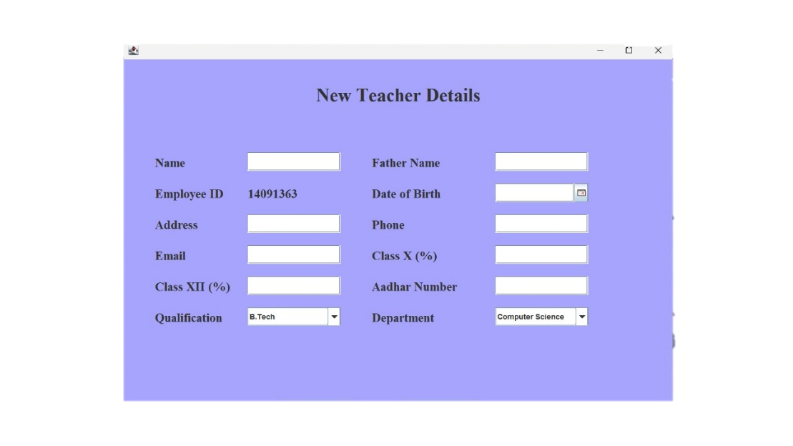

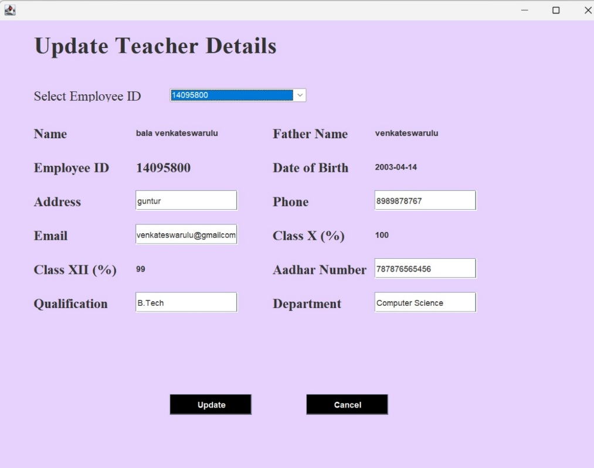

5. Student Details
Description:
Handle student data, including adding new students, viewing existing records, or updating details.
Actions:
- Add Student:
  - Go to New Information → New Student Information
  - Complete the form with ID, Name, Course, etc., and submit
- View Students:
  - Go to View Details → View Student Details
- Update Students:
  - Go to Update Details → Update Student Details
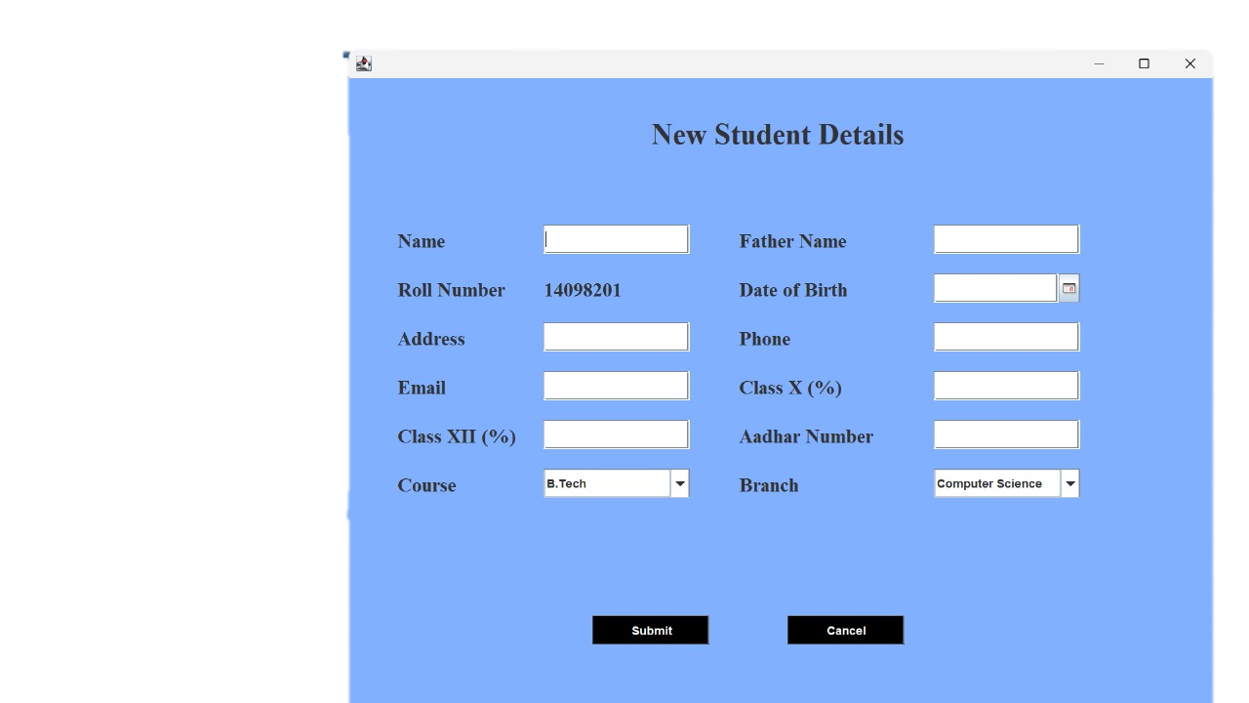

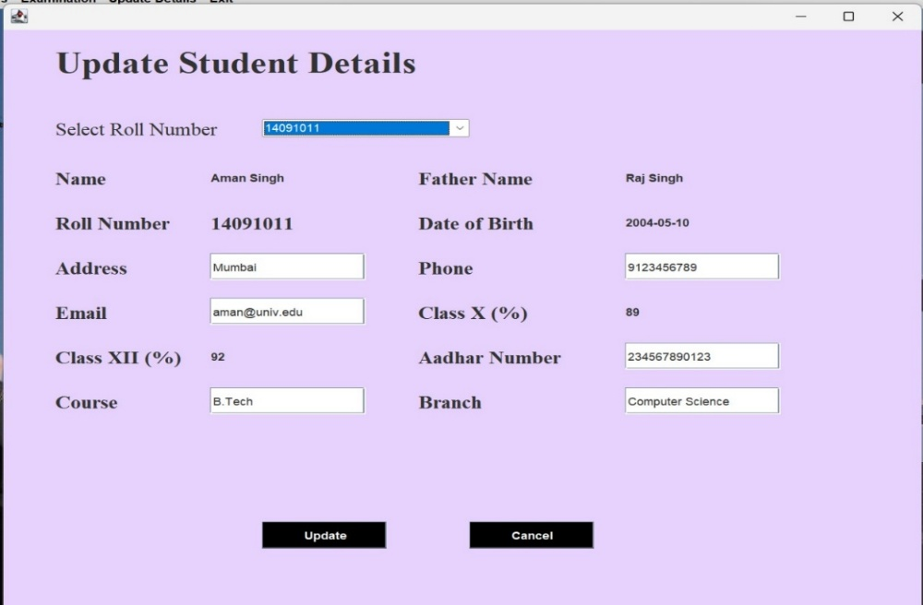

6. Check Academic Results
Description:
View each student’s academic performance across subjects and semesters.
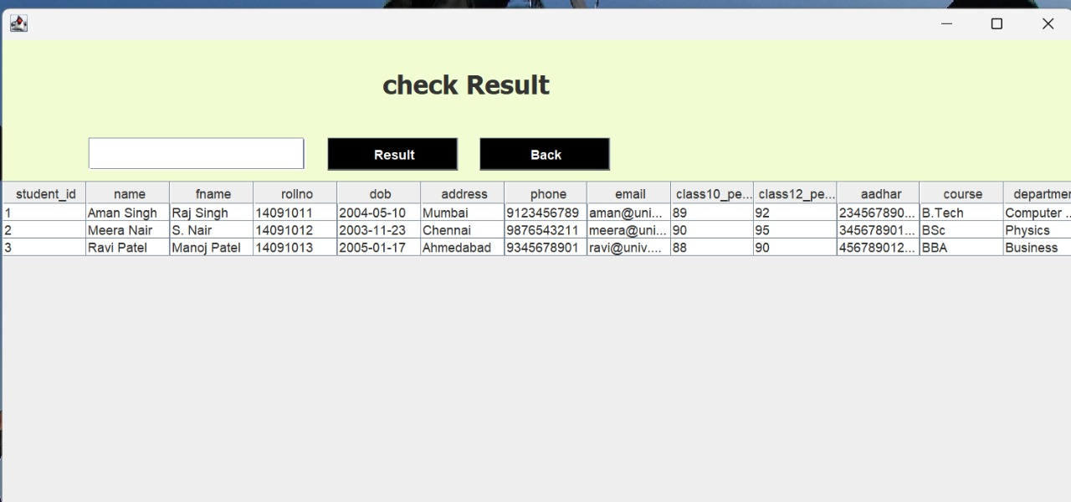
7. Enter Marks Sheet
Description:
Faculty can input marks for each subject a student is enrolled in.

